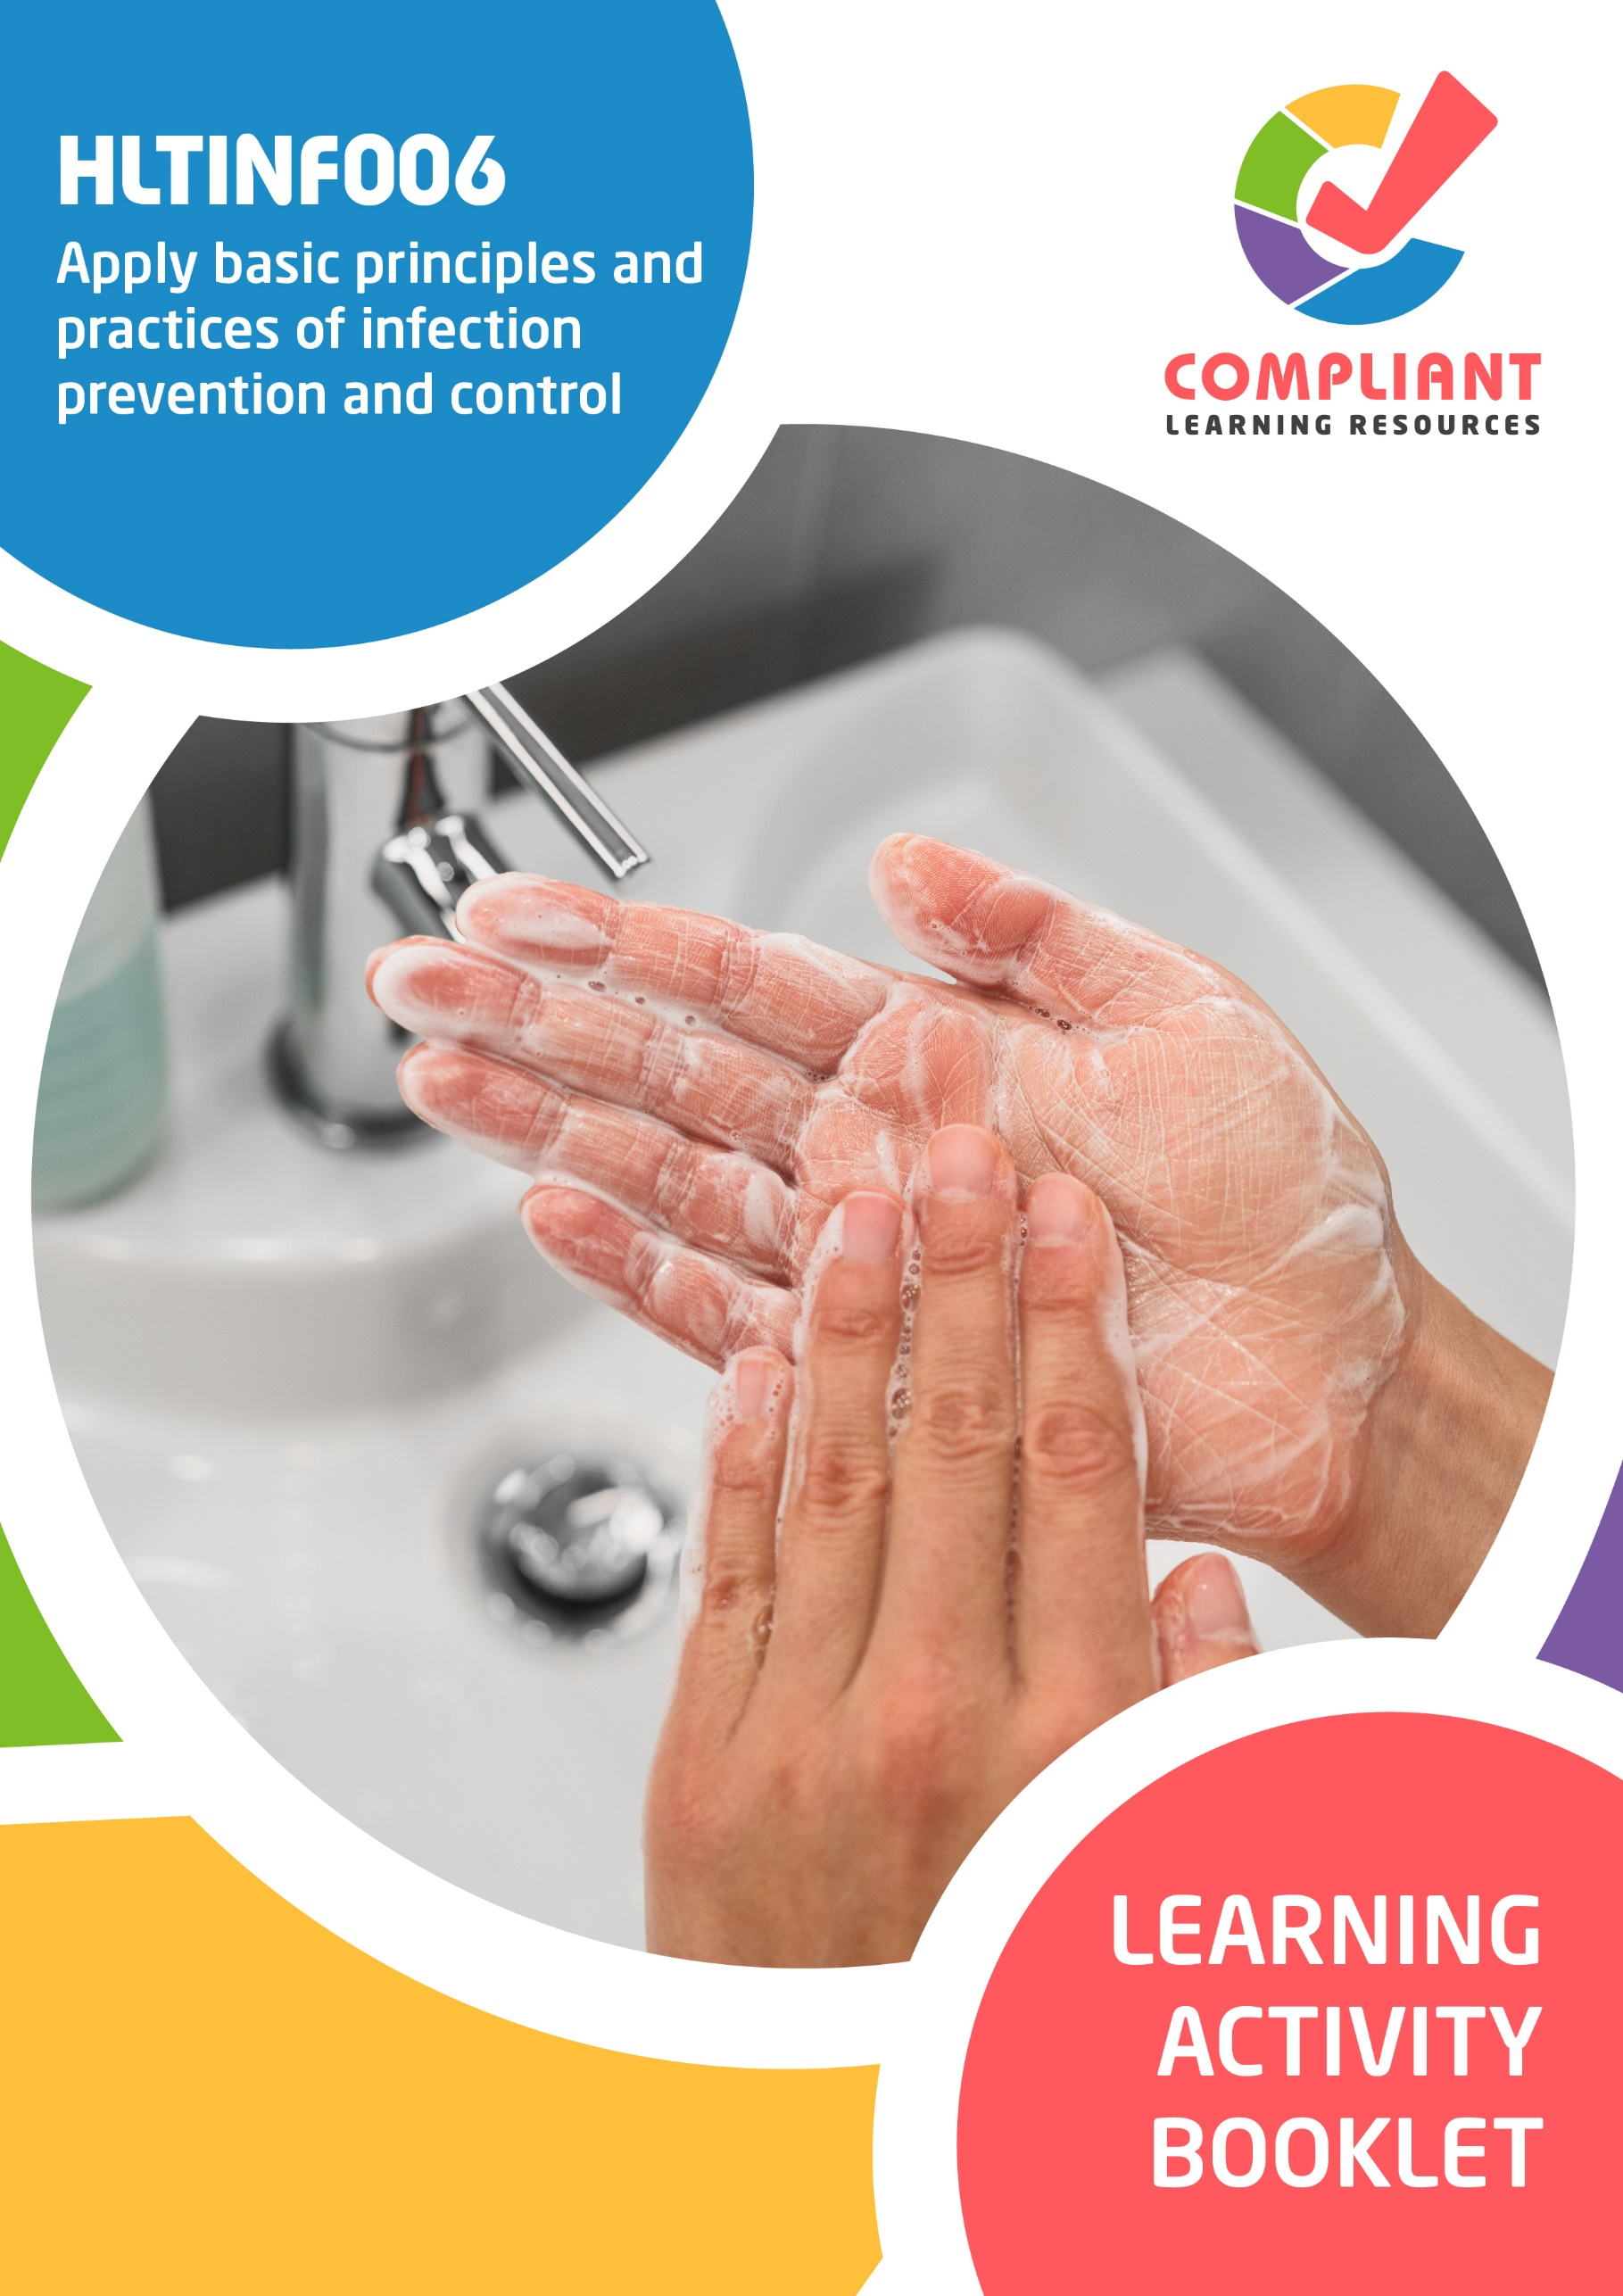

**Copyright**

This document was developed by Compliant Learning Resources.

© 2023 Compliant Learning Resources.

All rights reserved.

No part of this publication may be reproduced, stored in a retrieval system, or transmitted in any form or by any means, electronic, mechanical, photocopying, recording, or otherwise without the prior written permission of Compliant Learning Resources.

**Version Control & Document History**

|  |  |  |
| --- | --- | --- |
| **Date** | **Summary of Modifications** | **Version** |
| 25 January 2023 | Version 1.0 released for publishing | 1.0 |

# Table of Contents

Overview 4

Learner Instructions 5

Learner Information 5

Trainer Information 5

Resources Required 6

Work Health and Safety 6

Reasonable Adjustment 7

Formative Activities 8

I. Identify the Role of Infection Prevention and Control in the Work Setting 8

Activity 1.1 8

Activity 1.2 9

Activity 1.3 10

II. Follow Standard and Transmission-Based Precautions 11

Activity 2.1 11

Activity 2.2 12

Activity 2.3 12

III. Respond to Potential and Actual Exposure to Infection Risks 13

Activity 3.1 13

Activity 3.2 14

# Overview

**HLTINF006 - Apply basic principles and practices of infection prevention and control (Release 1)**

This unit describes the performance outcomes, skills and knowledge required to apply basic infection prevention and control principles in a workplace, including implementing standard and transmission-based precautions and responding to risks.

This unit applies to individuals working in a range of industry and work setting contexts.

The skills in this unit must be applied in accordance with Commonwealth and State or Territory legislation, Australian standards and industry codes of practice.

No occupational licensing, certification or specific legislative requirements apply to this unit at the time of publication.

**A complete copy of the above unit of competency can be downloaded from the TGA website:**

<https://training.gov.au/Training/Details/HLTINF006>

# Learner Instructions

This Learning Activity Booklet contains formative activities that learners will complete in the classroom or a similar environment.

These formative activities include knowledge questions to test your underpinning generic knowledge and practical activities to test your skills relevant to the unit/s of competency.

These formative assessments are used by your trainer to complement both the learning and training processes, and to evaluate how you are progressing throughout these processes.

You may reference your Learner Guide and other learning materials to complete the activities included in this workbook.

**IMPORTANT:**

**The completion of the formative assessments and learning activities included in this workbook DOES NOT lead to a Qualification or a Statement of Attainment (SOA).**

## Learner Information

|  |  |
| --- | --- |
| Learner name |  |
| Phone |  |
| Email |  |

## Trainer Information

|  |  |
| --- | --- |
| Trainer name |  |
| RTO name |  |
| RTO phone |  |
| RTO email |  |

# Resources Required

Resources needed to complete activities included in this workbook include:

* Computer with Internet, email access, and a working web browser
* Installed software: MS Word, Adobe Acrobat Reader
* Learner guide

# Work Health and Safety

Both the trainers and learners have duty of care in ensuring that the learning environment is free from hazards that may pose risks to their health and safety.

According to WHS legislation, trainers and learners must take reasonable care while undertaking the activities included in this workbook in the learning environment.

# Reasonable Adjustment

‘Reasonable adjustment’ in VET is the term applied to modifying the learning environment or making changes to the training delivered to assist a learner with a disability. A reasonable adjustment can be as simple as changing classrooms to be closer to amenities or installing a particular type of software on a computer for a person with vision impairment.

**Why make a reasonable adjustment?**

We make reasonable adjustments in VET to make sure that learners with disabilities have:

* The same learning opportunities as learners without disabilities, and
* The same opportunity to perform and complete assessments as those without disabilities.

**Reasonable adjustment applied to participation in teaching, learning, and assessment activities can include:**

* Customising resources and assessment activities within the training package or accredited course
* Modifying the presentation medium
* Learner support
* Use of assistive/adaptive technologies
* Making information accessible both before enrolment and during the course
* Monitoring the adjustments to ensure learner needs continue to be met

**Assistive/Adaptive Technologies**

Assistive/adaptive technology means ‘software or hardware that has been specifically designed to assist people with disabilities in carrying out daily activities’ (World Wide Web Consortium - W3C). It includes screen readers, magnifiers, voice recognition software, alternative keyboards, devices for grasping, visual alert systems, and digital note-takers.

*(Adapted Reasonable Adjustment in teaching, learning and assessment for learners with a disability - November 2010 - Prepared by - Queensland VET Development Centre)*

**IMPORTANT:**

**Reasonable adjustment made for collecting learner assessment evidence must not impact the standard expected by the workplace, as expressed by the relevant unit/s of competency. For example, if the assessment were gathering evidence of the learner’s competency in writing, allowing the learner to complete the assessment verbally would not be a valid assessment method. The method of assessment used by any reasonable adjustment must still meet the competency requirements.**

# Formative Activities

## I. Identify the Role of Infection Prevention and Control in the Work Setting

### Activity 1.1

|  |  |  |  |  |  |  |  |  |
| --- | --- | --- | --- | --- | --- | --- | --- | --- |
| **Matching Type**  Identify the means of infection transmission being described in each statement below.   |  | | --- | | **Means of Infection Transmission** | | Contact transmission | | Droplet transmission | | Airborne transmission | | Surface or object contamination | | Penetrating injuries | | Vectors | | |
|  | |
| Means of Infection Transmission | |
|  | 1. This happens when contaminated sharp tools or materials puncture the skin. |
|  | 1. This happens when pathogens in small particles called aerosols get dispersed in the air. |
|  | 1. This happens when other pathogen-carrying organisms like mosquitoes, ticks and fleas bite a person. |
|  | 1. This happens when a susceptible person touches a surface or object where pathogens have latched on. |

|  |  |
| --- | --- |
| Means of Infection Transmission | |
|  | 1. This happens when there is direct physical contact between the infected person and the susceptible person. |
|  | 1. This happens when the infected person coughs, talks or sneezes while the susceptible person is nearby. |

### Activity 1.2

|  |  |
| --- | --- |
| **True or False**  Review the statements below about the hierarchy of control. Indicate whether each statement is True or False.  Tick the box that corresponds to your answer. | |
|  | |
| TRUE  FALSE | 1. Elimination of risk is the most effective control measure. |
| TRUE  FALSE | 1. Substitution risk control separates the people from the hazard. |
| TRUE  FALSE | 1. PPE-related control measures are taken when hazard exposure is avoidable. |
| TRUE  FALSE | 1. Administrative controls are policies and procedures set by the management to minimise workplace risk. |
| TRUE  FALSE | 1. Engineering controls reduce risk by removing hazards completely. |

### Activity 1.3

|  |
| --- |
| Define the different degrees of pathogen exposure. |
|  |
| Exposure |
| Colonisation |
| Infection |
| Disease |

## II. Follow Standard and Transmission-Based Precautions

### Activity 2.1

|  |  |
| --- | --- |
| **Matching Type**  Listed below are the different types of Personal Protective Equipment (PPE).   1. Gloves 2. Masks 3. Protective Eyewear 4. Face Shields 5. Protective Clothing   Match each to their description below, by writing the letter that corresponds to your answer in the space provided. | |
|  | |
| Description | |
|  | 1. This protects the face, mouth, nose and eyes from infectious agents and other bodily fluids. |
|  | 1. This protects people from being exposed to pathogens that can be transmitted via hand contact. |
|  | 1. This protects the nose and mouth from exposure to blood, body substances, secretions and excretions. |
|  | 1. This protects the mucous membranes in the eyes from blood and other bodily fluids. |
|  | 1. This protects the workers’ uniforms, clothing and exposed body parts. |

### Activity 2.2

|  |
| --- |
| **Fill in the blanks**  The following are statements about waste management. Review each and complete the statement by filling in the missing words/phrases. |
|  |
| 1. refers to waste material that has not come into contact with reservoirs of infectious agents. |
| 1. contains infectious material, blood, bodily fluids or other contaminants that can cause injury, infection or disease. |
| 1. waste refers to the process of retrieving waste material in storage. To do this, you need to make sure that you wear appropriate      . |
| 1. should be contained in a leak and puncture-proof container. |
| 1. is an automated, enclosed process. It involves using       to reduce the volume of waste before it is taken to a treatment or disposal facility. |

### Activity 2.3

|  |
| --- |
| Enumerate the steps to take in alcohol-based hand rubbing. |
|  |
|  |
|  |
|  |
|  |
|  |
|  |
|  |

## III. Respond to Potential and Actual Exposure to Infection Risks

### Activity 3.1

|  |  |  |  |  |  |  |  |  |
| --- | --- | --- | --- | --- | --- | --- | --- | --- |
| **Matching Type**  Identify the people who you report to in the workplace about infection-related incidents being described in each statement below.   |  | | --- | | **People in the Workplace to Whom Reports May be Made** | | Supervisors | | General practitioners | | Health care professionals | | Carers | | Responsible persons | | Responsible authority | | |
|  | |
| Description | |
|  | 1. They have duties and responsibilities related to health and safety in the workplace. Workers and colleagues in the same role usually fall under this. |
|  | 1. They are tasked with overseeing the well-being of other individuals. |
|  | 1. They are doctors who you can report health-related information to. |
|  | 1. They are in a high position of authority in the workplace. |

|  |  |
| --- | --- |
| Description | |
|  | 1. They are composed of nurses, receptionists, pharmacists or other job roles related to health care. | |
|  | 1. They are people with duties and responsibilities related to overseeing health and safety in the workplace. They may include PCBUs and health officers. | |

### Activity 3.2

|  |
| --- |
| **SCENARIO**  ABC Clinic is a small health clinic that employs 25 people. This facility follows the Australian guidelines set by the National Health and Medical Research Council (NHMRC) for preventing the spread of infection in the workplace.  Glen is a health worker at ABC Clinic. It is winter season, and the temperature has dropped significantly. One day, he noticed a colleague looking pale while working. This person has also been coughing and sneezing every now and then. After several days, he observed that the number of people with coughs and colds had increased.  As a healthcare worker, Glen is responsible for developing measures to prevent this situation from worsening. He must think of ways to reduce the transmission of infectious agents in his workplace. |

|  |
| --- |
| What can Glen do to reduce the transmission of infectious agents in his workplace? |
|  |
|  |

End of Document